RESOLUTION NO.__________

RE: CERTIFICATE OF APPROPRIATENESS UNDER THE
PROVISIONS OF THE ACT OF THE PENNSYLVANIA
LEGISLATURE 1961, JUNE 13, P.L. 282 (53
SECTION 8004) AND BETHLEHEM ORDINANCE NO.
3952 AS AMENDED.

The applicant proposes to replace the porch “in-kind” and is seeking approval for the color scheme at 450 High St.

NOW, THEREFORE, BE IT RESOLVED by the Council of the City of Bethlehem that a Certificate of Appropriateness is hereby granted for the proposal.

Sponsored by: (s)

(s)

ADOPTED BY COUNCIL THIS DAY OF

(s)
President of Council

ATTEST:

(s)
City Clerk

HISTORICAL & ARCHITECTURAL REVIEW BOARD

The applicant proposes to replace the porch “in-kind” and is seeking approval for the color scheme at 450 High St.

APPLICATION #1:

Jennifer Hawk
450 High St.
Bethlehem, PA 18018

OWNER:

__________________________________________________________________________

The Board upon motion by Beth Starbuck and seconded by Diana Hodgson adopted the proposal that City Council issue a Certificate of Appropriateness for the following:

- To replace the porch “in-kind” and are to add a non-slip additive to the wooden
steps.

2. Color scheme as follows: all paint to be Benjamin Moore Historic Colors, floor
#HC-85, rails #HC-86 and 126, trim #HC-86 and front door #HC-124.

2. The motion was unanimously approved.

__________________________________________________________________________

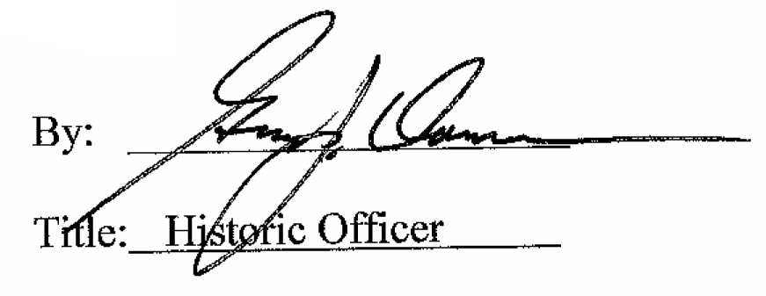

Date of Meeting: May 2, 2018

